## Milestone 3:

Our site can be viewed at: <insert LINK>

## Items Completed for this Milestone:

* Base CSS created for site
  + Design implemented through flexbox
  + Forms designed
  + Tables designed
  + Layout finalized
* All pages created and written in HTML
  + Validated CSS, HTML, and Accessibility
* A/B testing of design elements

## Key Issues

We some difficulty creating a Stylesheet that would work for the multiple layouts we use on our site. It was somewhat difficult to try to reduce the number of classes we implemented in CSS. The balance of desired features and cross-compatibility was also difficult in the design phase.

## Deviations from initial design

We altered our design slightly to have a page wide banner, as after testing we felt we had a better response to the page-wide design. We changed the color palette slightly but maintained the theme for which we were aiming.

## Documentation:

Home Page:

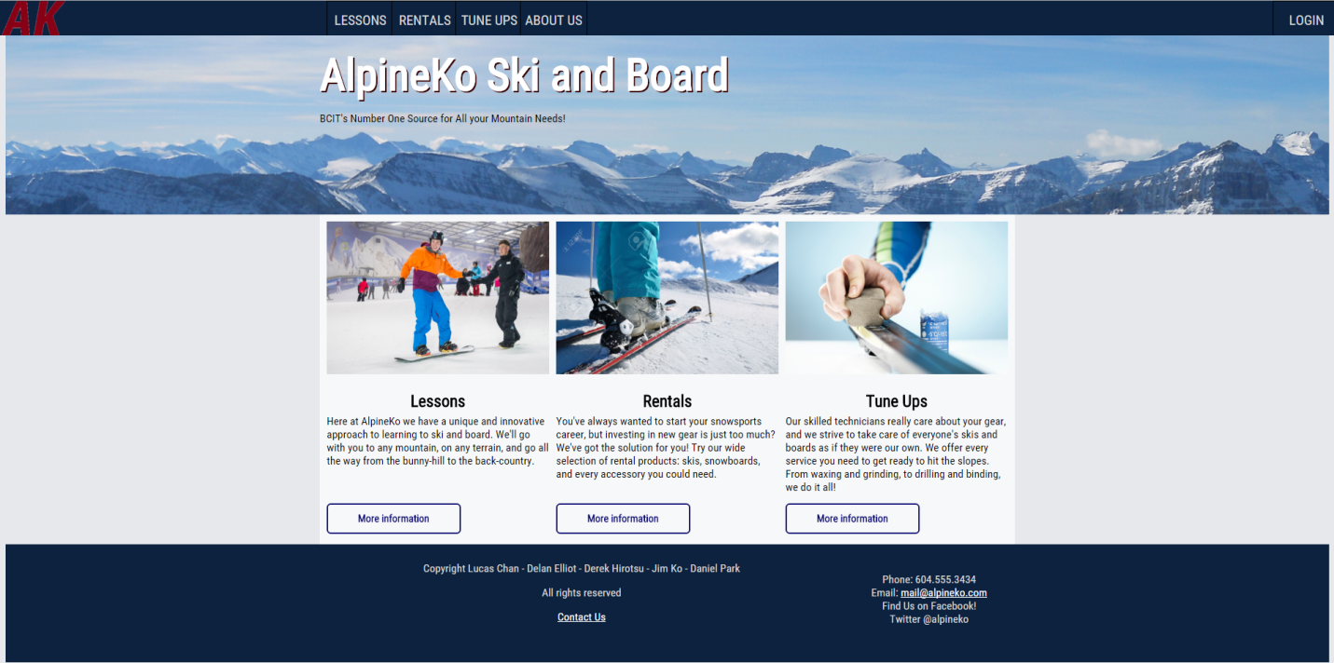

Rental Page (with form and table markup):

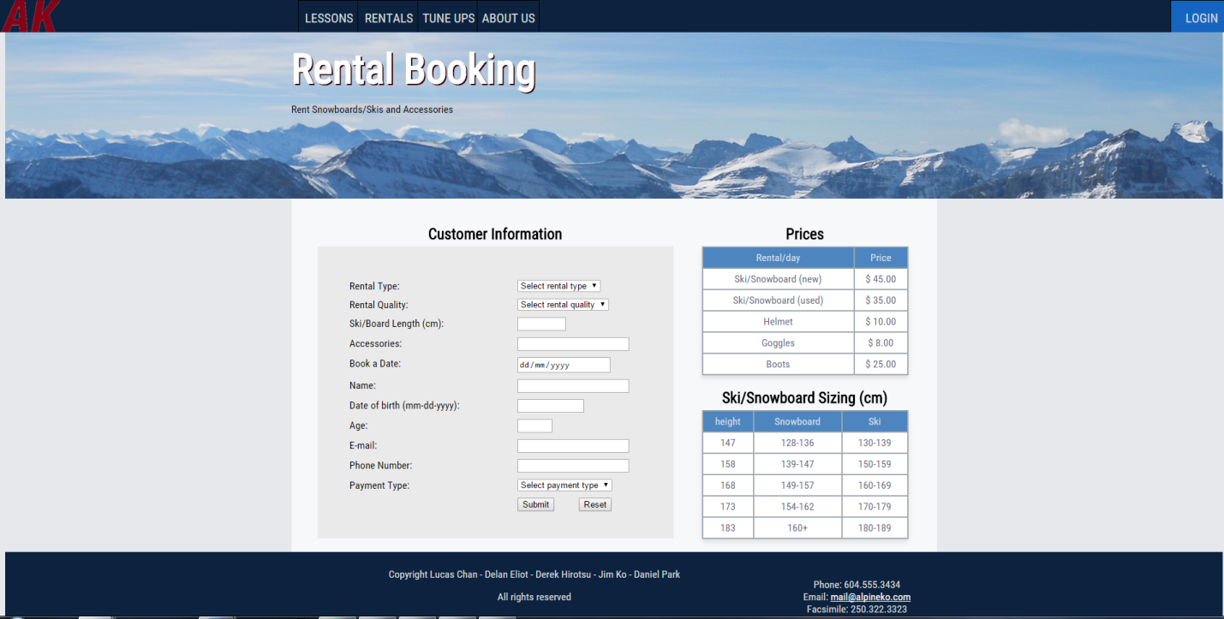

## A/B Testing:

**Lessons Page**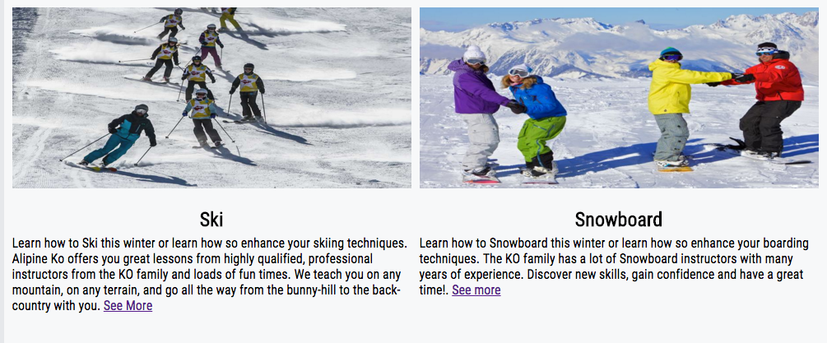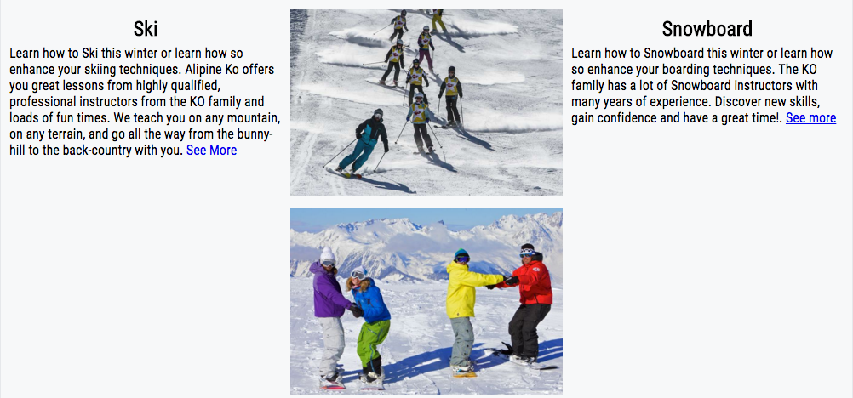

Tested visuals to see what would look more appealing to the user. The first one consists of only 2 divs the second one has 3 divs 1 is set for only the images.

**Skiing Lesson Page**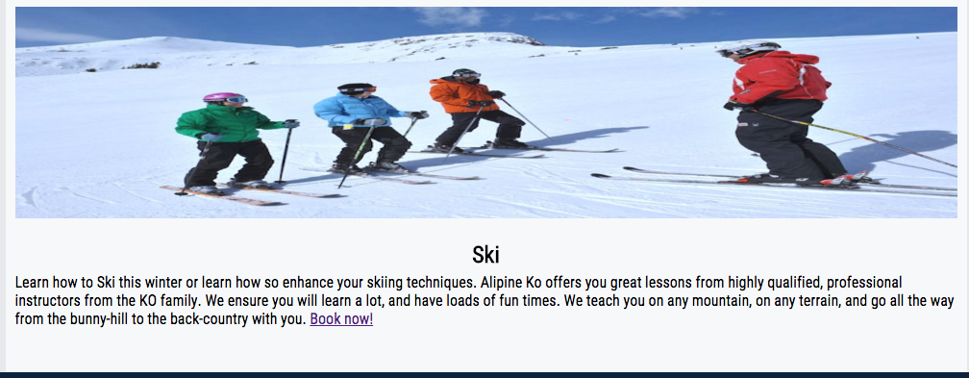

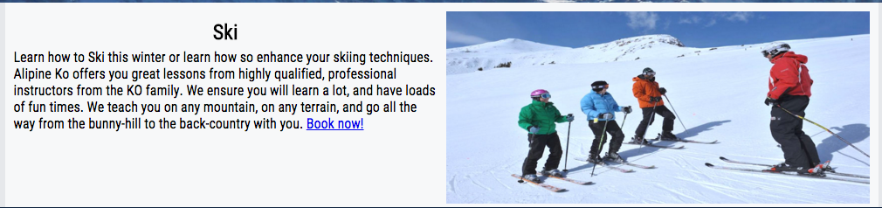

Tested making the image its own dev so it would sit next to the text compared to the image being above the text.

**Snowboard Lessons Page**